ROUGH IDEA TEMPLATE:
One idea per page. Body copy is not necessary to write at this point, but can be indicated with lines. You may attach a photo if you wish but you still must sketch the idea as best you can. Don’t forget to communicate a benefit of some sort – either a human benefit or a product benefit.
target profile (Demographic/Psychographic): elderly population and the young generation.

PRODUCT/FACT: fast drinks ready for drinking.
main message / benefit: individuals whose taste and preference is based on buying readymade coffee.

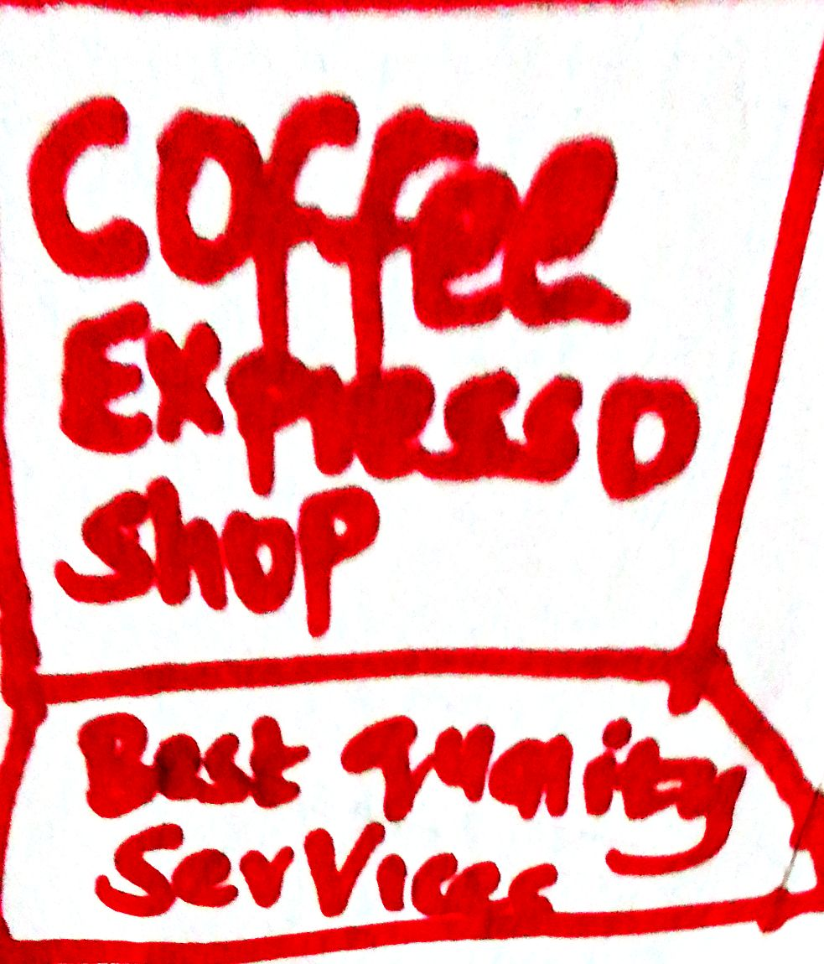

visual explanation (if needed):
we are focused on availing fast drinks to our customers who are busy and lack time to sit in the restaurants to drink.

